LORA TECHNOLOGY

Aim: To build an IOT (Internet of things)application using the Lora technology.

About LORA:-LoRa (Long Range) is a patented digital wireless data communication technology developed by Cycleo of Grenoble, France, and acquired by Semtech in 2012.LoRa uses license-free sub-gigahertz radio frequency bands like 169 MHz, 433 MHz, 868 Mhz (Europe) and 915 MHz (North America). LoRa enables very-long-range transmissions (more than 10 km in rural areas) with low power consumption.The technology is presented in two parts— LoRa, the Physical later and LoRaWAN (Long Range Wide Area Network), the upper layers.
LoRa and LoRaWAN permit inexpensive, long-range connectivity for Internet of Things (IoT) devices in rural, remote and offshore industries. They are typically used in mining, natural resource management, renewable energy, transcontinental logistics, and supply chain management.
Equipment Required:
1.two RYLR896 modules
2.two ARDUINO’s.
3.Breadboard and resistors(10k,4.7k) and connecting wires.
About RYLR896

The RYLR896 transceiver module feature the Lora long range modem that provides ultra-long range spread spectrum communication and high interference immunity whilst minimising current consumption.

FEATURES
- SX1276 Engine
- Excellent blocking immunity
- Low receive current
- High sensitivity
- Control easily by AT commands
- 127 dB Dynamic Range RSSI
- Designed with PCB integrated antenna
- AES128 Data encryption
APPLICATIONS
- IoT Applications
- Mobile Equipment
- Home Security
- Industrial Monitoring and Control Equipment
- Car Alarm
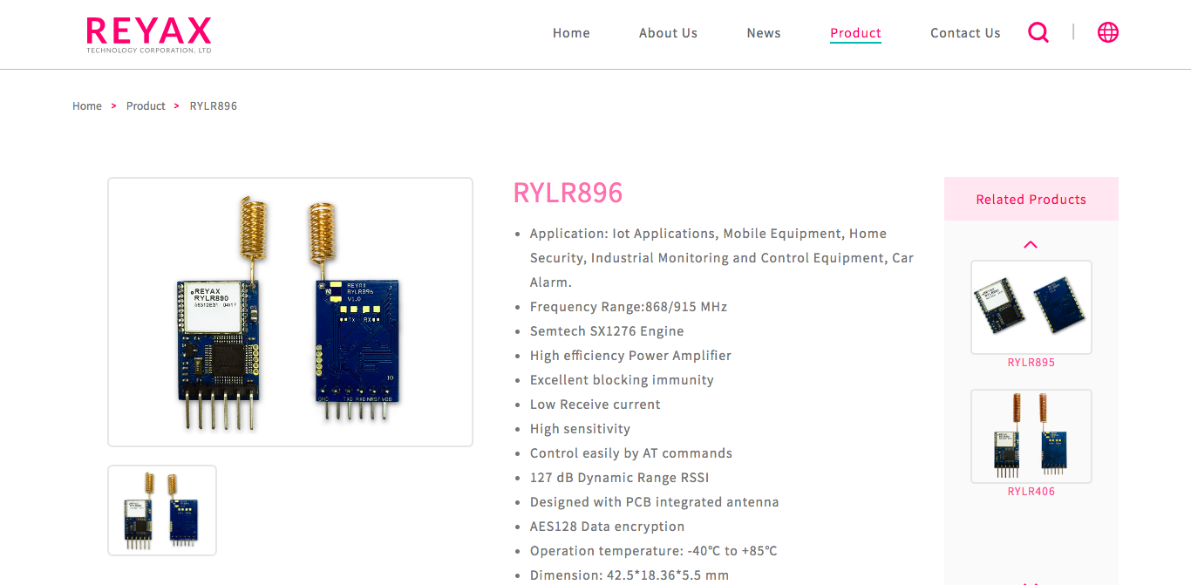
The Sequence of using AT commands

1.use “AT+ADDRESS” to set ADDRESS. ADDRESS is regard as the identification transmitter or specified receiver.
2.Use “AT+ NETWORKID” to set the ID of the lora network.This is a group function. Only by setting the same NETWOKID can the modules communicate with each other.If the address of the specified receiver is belong to different group,it is not able to communicate with each other. use 1 to 15.
3.use “AT+BAND” to set the center frequency of wireless band. The transmitter and the receiver required to use the same band frequency to communicate with each other.
4.use “AT+PARAMETERS” to set the wireless RF parameters. The transmitter and the receiver required to set to the same parameters to communicate with each other.
5.use “AT+SEND” to send the data to the specified ADDRESS. use”lora modem calculator tool”to calculate the transmission time.
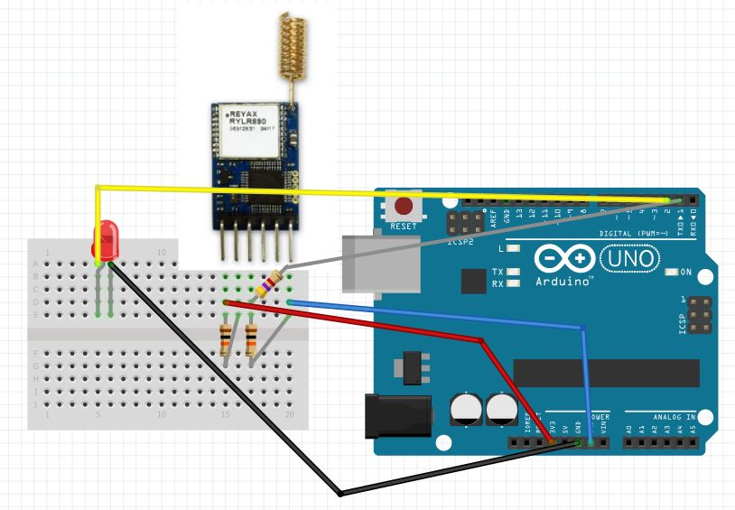
Transmitter connection

2.Receiver connection
